**Developing an Electronic Patient Profile**

**for Albanian Hospitals**

By

Ardi Bandilli

Prof. Loren Gjermeni



A THESIS

Submitted to

**KOLEGJI UNIVERSITAR “Instituti Kanadez i Teknologjisë”**

**University College “CANADIAN INSTITUTE OF TECHNOLOGY”**

**Faculty of Engineering**

**Department Software Engineering**

In partial fulfillment of the requirements for the degree of:

**Bachelor in Software Engineering**

Submitted on September 5th, 2018

Bachelor in Software Engineering

Submitted on September 5th, 2018

Approved:

_________________________________________ Prof. Loren Gjermeni

(signature)

_________________________________________ Prof. Fabjan Lashi

(signature)

I understand that my thesis will become part of the collection of Canadian Institute of Technology. My signature below authorizes release of my thesis to any reader upon request. I also affirm that the work represented in this thesis is my own work.

___________________________ Ardi Bandilli, Author

(signature)

**Abstract**

My thesis represents a management software system called Hospitalb.This software features the first Albanian software which will help and improve all national hospital services by its characteristics. From my experience and from what I have seen so far, Albanian hospitals lack on electronic and online services. Every Albanian citizen is used to stay in lines for hours only to book a medical examination. Also their medical records are maintained in old papers, which unfortunately get lost. Hospitalb will have the ability to overcome this problems.

The software will consist in 3 main interfaces or management panels , one for the administrators, which will have the possibilities to add, edit and delete doctor’s accounts and other administrator’s accounts. Doctors interface is the second main interface which will give the doctors the possibilities to search for a patient’s profile or create a new electronic patient profile. The third interface is the patient’s interface which will give the patient the possibility to view his medical profile and book an examination visit based on the criteria selected. This interface is planned to be developed in later stage.

Hospitalb will be a web application software developed by programming languages like HTML, CSS, Bootstrap, Javascript and JQuery for the front-end implementation and PHP for the back-end implementation. For the database it will be used MySQL, which will handle the storing of the data.Later in the process Node.js will be implemented to help on deploying this application onto the cloud and making it accessible by every operating system and by every electronic means (smartphones, tablets)

**Keywords** Hospitalb, services, administrator, doctor, patient, medical record, profile , HTML, CSS, Bootstrap, Javascript, JQuery, PHP, MySQL, front-end, back-end, cloud.

**I. Authentication**

Hospitalb is planned to be used by three parties and since there are three different interfaces implemented, even the authentication part should be separated. The main interface of the application , which is also the home page, contains a navigation panel on which resides 4 important HTML components assigned for the authentication purposes.  
 For administrators and doctors there are dedicated email and password input fields, also a submit button labeled “Login”. Since both parties have different interfaces the “name” variable of the “roles” database table would play a huge factor. After the POST method request invoked by the submit “Login” button, a query will run on MySQL database to identify the email and the password of the parties. When these inputs are correct and true another query will fire up to provide the corresponded “name” from “roles” table of the logged in user, which by implementing a PHP condition statement , this “name” variable will provide the corresponded interface based on the result of the statement, if name is equal to admin, doctor or patient.

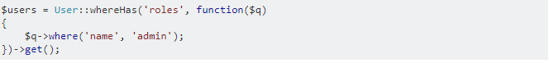

Patient authentication it is a bit tricky since it is planned that the patients won’t be allowed to create an account with an email address and password, but only to view their medical records and book a medical examination visit. Having this in mind, we would need to add another submit button in the navigation panel labeled “Login as a Patient”. This button will redirect the patient to his/her login interface.  
 The authentication of the patient is planned to be done by entering his/her full name and health booklet identification number. Patients without a health booklet would not be able to use this web application. The POST method request of the form will invoke a MySQL query to search and identify the correct patient and redirect him/her to the personal profile.  
 Each authentication will be followed by front-end validation written in JavaScript and back-end validation written in PHP. The validations are required to maintain a decent and secured web application.

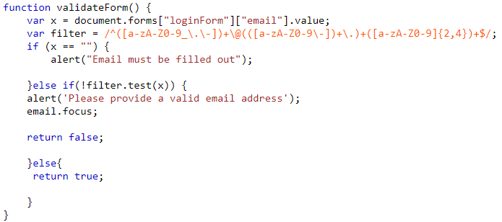

**II. Administrator Panel**